oliver cable

Implementing algorrithm in code and debugging in IDE
Progamming

Table of Contents
Introduction 2
Pseudocode 2
Debugging Process and IDE Facilities (Apache NetBeans) 4
Coding Standards Used 6
Conclusion 6
AI Declaration 7
References 7

Introduction
This report will be about a Project I’ve been assigned to create by MicroTech (my employer) for a client. The client has asked for a module “Password Strength checker” for one of their CRM applications that will help them to check the strength of the password, based on the password security policy of the client. The client has three security policies being; the length of the password should be a minimum of 8 characters, the password should include both uppercase and lowercase, and should include numbers and special characters. This will allow the user to check the strength of their password if it's weak, moderate, or strong. If the password meets all the security policies, then it will be considered strong. The project will be developed using Java in the Apache NetBeans IDE.
The project will be developed using object-oriented programming concepts and a graphical user interface, along with Apache NetBeans being used to test and debug the program. Also, before developing the code using the IDE, I will write a pseudocode section to show the algorithm in practice.
This report will start by showing the pseudo-code used in the making of the project, a section on the debugging processes I used, along with the tool/help given while using Apache NetBeans, then a section explaining what coding standards were used during the development, and finally a conclusion to reflect on how the project went and how successful the end product was.

Pseudocode
This section will show the Pseudocode used during the development of the algorithm for my Password Checker.
START

CREATE Password Strength Checker window
SET window size = 600 x 250
SET window title = "Password Strength Checker"
DISPLAY GUI components:
- Label: "Enter Password:"
- Text field for password input
- Button: "Check Strength"
- Label for result

WHEN user clicks "Check Strength" button DO
READ password from text field
SET score = 0

IF length(password) >= 8 THEN
score = score + 1
END IF

IF password contains lowercase letter (a-z) THEN
score = score + 1
END IF

IF password contains uppercase letter (A-Z) THEN
score = score + 1
END IF

IF password contains a number (0-9) THEN
score = score + 1
END IF

IF password contains a special character (not a-z, A-Z, 0-9) THEN
score = score + 1
END IF

IF score <= 2 THEN
DISPLAY "Password Strength: WEAK"
ELSE IF score <= 4 THEN
DISPLAY "Password Strength: MODERATE"
ELSE
DISPLAY "Password Strength: STRONG"
END IF
END WHEN

END

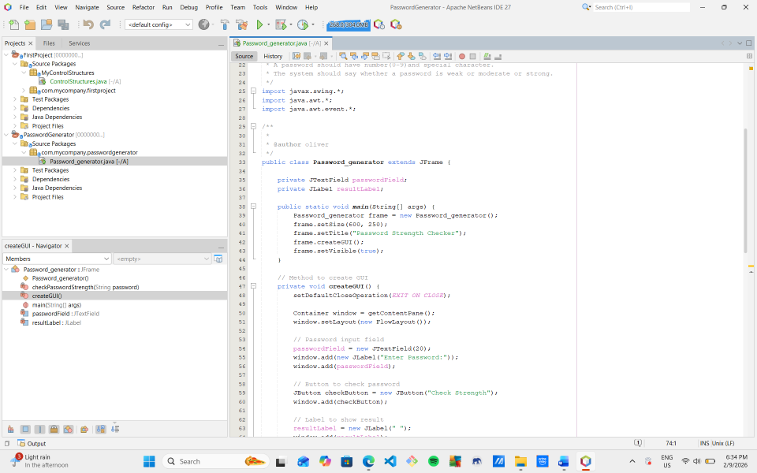
This algorithm has been implemented via Apache NetBeans IDE.

Debugging Process and IDE Facilities (Apache NetBeans)
The debugging process of finding, isolating, and resolving coding errors, known as bugs in software programs. This allows the developer to find what may be causing the coding errors, and prevent the software from possible function issues, and improve the overall performance of the code/project.
The most common coding errors are syntax errors, logical errors, runtime errors, and semantic errors that can end up causing the programme to crash.
Syntax errors
This is an error that occurs when the developer misses a part of the code, with examples like brackets, parentheses, commas, or other typographical errors. Unlike when people use language to communicate, where some typographical or grammatical errors can still be understood, missing the smallest part of code will immediately lead to an error.
This was the most common error I encountered while writing my Java code, such as little mistakes, forgetting to add a comma to close a statement, or using a comma/semi-colon to close a bracket. This is where NetBeans comes in handy, as some syntax errors are detected automatically while the code is being written. If there is a missing syntax or a misspelled method/variable, the IDE highlights the line of code where the error has taken place with a little icon that, if hovered over, will display the error message incurred.
This allowed me, while writing the code out, to easily identify any sections of code with a syntax error immediately and then correct them before even having to run the code in the IDE. This helps to reduce the time of development as syntax errors can be immediately corrected instead of building up and then only being visible when the program has been run, which can be hard to fix if there are multiple syntax errors popping up throughout the coding process.
Logical errors
This is where the code is able to run, but ends up giving the wrong desired output or only part of the needed output. Because the syntax of the code is correct, the IDE is unable to show where the error has occurred, making it more difficult and time-consuming to detect, as the code doesn’t crash at the error, masking the exact location of the incorrect code.
This error only happened a couple of times, with the desired output only displaying a part of the variable and not the full variable. The first example was when the code was only able to score lowercase letters within the Password Checker GUI, with all uppercase letters automatically resulting in the display showing that the password was classed as “Weak” even though it should have been classed as “Moderate” or “Strong” as the code wasn’t adding the value given to the uppercase letter to the end score. Apache NetBeans came in handy for this, as if you require help, it gives you access to a website showing the correct formatting that can be applied, along with examples. Also, if the Alt Enter command is given, the IDE is able to show viable solutions where the error is given if it shows up during the running of the program.
Semantic errors
This is where a piece of code violates the rules given within the coding language, causing a semantic error. This means that the IDE is unable to understand what the code means and will end up not producing a meaningful output.
This error only occurred once when developing my code, with part of the starting variable needed to create the score, unable to add up the score given to the GUI when a password was entered, resulting in a score higher than the maximum possible being calculated, breaking the possible results. This was rather hard to fix, as NetBeans was unable to show me where the error had occurred, resulting in me rewriting that entire section of code out again till the desired result occurred, fixing my issue.
Runtime errors
This happens when an error occurs during the running or start-up of the application or GUI. They can be fixed by refreshing, restarting, or reinstalling the necessary parts of the project. If it remains unfixed, then it can signal that the program is unable to run due to the requirements of larger amounts of memory or another type of error, such as a logical error.
One issue was that when clicking the button Enter, the result did not end up updating on the GUI. This was caused by an action listener variable not calling on the correct Password Checker method. After checking the event handling section of code, I was able to correct the method call so that the password entered by the user was able to pass to the strength detector function.
Another error that occurred when creating the GUI was that the result label updated incorrectly, but this ended up being part of a logic error described earlier, rather than a runtime error. This shows that not every error is the one you think it is.
Using Breakpoints
This is a type of debugging where a developer creates an intentional place in the code where they want the execution to stop, allowing them to examine the program data and/or state. This could be when a special breakpoint instruction is given to the processor, so it stops and waits for the debugger.
Step Execution
This is where a command is given; the code only executes line by line, allowing the processor to also follow the logic line by line, making it easier to show where an error may be taking place. In Apache NetBeans, commands like “Step Into”, “Step Over”, and “Continue” can be given to help in this type of debugging.
Variable Inspection
This is where the IDE allows the user to see real-time viewing of the values entered during the code's execution, making it possible to check the password entered by the user, the value of the score counter, and whether conditions were being triggered.
Test Cases
This is where the developer uses many different test cases to make sure the program's code is able to execute all security policies provided by the client.
Overview of the Benefits of Using NetBeans for Debugging
Using Apache NetBeans improved the development process by:
- Automatically identifying syntax errors
- Providing visual debugging tools
- Allowing step-by-step execution
- Making variable tracking easier
- Reducing development time
Overall, the debugging tools helped ensure that the final program was reliable and worked as intended.

Coding Standards Used
Coding standards are very important to follow when creating new projects, as they enable the code to have consistency, making it easier for other developers to read, understand, and, if needed, maintain the code. It also increases the readability of the code, which helps in reducing the potential for errors and improving collaboration, which can be very important when developing projects for a client, as they will need to take over when delivered and build upon it in the future (scalability).
Naming Conventions
Choose meaningful names that are able to convey the purpose of the variable or function, as it enhance the clarity and maintainability of the code. Also, different types of formatting cases can be followed when writing code, such as in this project, I used Pascal Case (Upper Camel Case), where the names start with a capital letter.
Code Formatting and Indentation
Code becomes more readable when it's easy to follow and optimises space and time. Examples would be:
- Write as few lines as possible
- Segment blocks of code in the same section into paragraphs
- Use indentation to mark the beginning and end of control structures and specify the code between them
- Create simple functions carrying out a single task
- Try not to repeat code as it's inefficient
- Avoid nesting too deeply, as it can become harder to read
Comments
Comments allow for the documentation to follow each section or line of code, helping to explain the logic, functionality, and purpose of a specific section. Comments help other developers to understand complex sections of code with ease.

Conclusion
In conclusion, I was able to successfully develop a Password Checker using the IDE, Apache NetBeans, and Java. The program allowed the user to enter a password and receive a score on the strength based on the security polices given by my client. With the use of pseudocode, I was able to plan the structure of my algorithm and then use object-oriented programming and a GUI to develop a solution.
The use of Apache NetBeans allowed for easier debugging with the tools it provided, helping to resolve issues quickly and ensure the program worked correctly with different test cases. Also, the use of Coding standards like naming conventions, indentation, and comments improved the readability and maintainability of the code.
Overall, the project showed how to structure an algorithm, how to use an IDE for the purpose of debugging and development, and the importance of following coding standards. I believe the finished project was able to meet all the requirements of the client while being a simple but effective tool for scoring password strengths.

AI Declaration
AI Use statement
The following software and AI tools have been used in the creation of this work:
Tool | Use
Grammarly | To check spelling and grammar
ChatGPT | To understand the passing criteria and source ideas

References
Apache Software Foundation (2026) Apache NetBeans. Available at: https://netbeans.apache.org/front/main/index.html (Accessed: 9 February 2026).
IBM (2024) What is debugging? Available at: https://www.ibm.com/think/topics/debugging (Accessed: 9 February 2026).
National Cyber Security Centre (2026) National Cyber Security Centre. Available at: https://www.ncsc.gov.uk/ (Accessed: 9 February 2026).
BrowserStack (2025) Coding standards and best practices. Available at: https://www.browserstack.com/guide/coding-standards-best-practices (Accessed: 9 February 2026).

